

**Tribhuvan University**

**Faculty of Humanities and Social Sciences**

**Tech Store**

**E-COMMERCE PROJECT REPORT**

**Submitted to**

**Department of Computer Science and Application**

**Mechi Multiple Campus**

***In partial fulfillment of CACS 301 MIS & E-Business requirements for the fifth semester of the Bachelor of Computer Applications program***

Submitted by:

Santosh Bhandari

Roll No: 58

Student’s Name 2

Roll No:

Under the Supervision of

**Pramod Kumar Soni**



**Tribhuwan University**

**Faculty of Humanities and Social Sciences**

**Mechi Multiple Campus**

**Supervisor’s Recommendation**

I hereby recommend that this report prepared under my supervision by **Santosh Bhandari** entitled **“Tech Store”** in partial fulfillment of CACS301 MIS & E-Business requirements for the fifth semester of the Bachelor of Computer Applications program is recommended for the final evaluation.

………………………………

Mr. Pramod Kumar Soni

**SUPERVISOR**

Lecturer

Department of Computer Science and Applications

Mechi Multiple Campus

Bhadrapur, Jhapa



**Tribhuwan University**

**Faculty of Humanities and Social Sciences**

**Mechi Multiple Campus**

**LETTER OF APPROVAL**

This is to certify that this project prepared by Santosh Bhandari entitled “**Tech Store**” in the partial fulfillment of the requirements for the degree of Bachelors in Computer Application has been evaluated. In our opinion, it is satisfactory in the scope and quality for the required degree.

|  |  |
| --- | --- |
| …………………………………….  **Supervisor**  Pramod Kumar Soni  Lecturer  Department of Computer Science and  Applications, Mechi Multiple Campus  Bhadrapur-08, Jhapa. | …………………………………….  **Program Director**  Keshev Kafley  Lecturer  Department of Computer Science and  Applications, Mechi Multiple Campus  Bhadrapur-08, Jhapa. |
| …………………………………….  **Internal Examiner** | …………………………………….  **External Examiner** |

# ABSTRACT

Tech Store stands at the forefront of technology retail, offering a comprehensive array of high-quality products catered to digital enthusiasts. Specializing in Computer Components, Laptop Accessories, Computer Accessories, and Network Components, our store is a go-to destination for individuals seeking top-tier solutions to enhance their digital experiences.

Immerse yourself in our collection, meticulously selected to meet the evolving demands of the tech-savvy consumer. From powerful Computer Components to sleek Laptop Accessories, versatile Computer Accessories, and cutting-edge Network Components, Tech Store provides a diverse range of products to elevate every aspect of your digital lifestyle.

With a commitment to quality and innovation, Tech Store ensures that each product aligns with the latest technological advancements. Whether you're upgrading your computer, accessorizing your laptop, enhancing your desktop setup, or building a robust network infrastructure, our store is your trusted partner in navigating the digital landscape.

# ACKNOWLDEGEMENT

We would like to express our special thanks of gratitude to our lecturer as well as our supervisor Mr. Pramod Kumar Soni for all his support and who gave us the golden opportunity to carry out this wonderful E-Commerce project on the topic ‘Tech Store”, which also helped us in doing a lot of research and we came to know about many things and ideologies regarding the topic.

We are over helmed in all humbleness and gratefulness to acknowledge our depth to all those who have helped us to put these ideas, well above the level of simplicity and into something concrete. We would also like to express our special thanks of gratitude to Mr. Keshev Kefley, BCA Program Director, Mechi Multiple Campus (MMC) and all staff of MMC for their valuable support in doing this E-Commerce project.

Any attempt at any level cannot be satisfactorily completed without the support and guidance of our parents and friends. Therefore, we would like to thanks our parents who helped us a lot in gathering different information and guiding from time to time in making this project despite of their busy schedule.

Santosh Bhandari

**Table of Contents**

ABSTRACT 1

ACKNOWLDEGEMENT 2

List of Figures 5

List of Tables 6

ABBREVIATIONS 7

Chapter 1: Introduction 1

1.1. Introduction 1

1.2. Problem Statement 1

1.3. Objectives 1

1.4. Scope and Limitation 1

Chapter 2: Background Study and Literature Review 2

2.1. Background study 2

2.2. Literature Review 2

Chapter 3: System Analysis and Design 3

3.1. System Analysis 3

3.1.1. Requirement Specification 4

3.1.4. Process Modeling (DFD) 6

3.2. System Design 6

3.2.1. System Architecture 6

3.2.3. Interface Design (UI Interface/ Interface Structure Diagrams) 7

Chapter 4: Implementation and Testing 8

4.1. Implementation 8

4.1.1. Tools Used 8

4.1.2. Modules and Plugins Used 9

4.2. Testing 10

4.2.1. Test cases for Unit Testing: 10

Chapter 5: Conclusion and Future Recommendation 11

5.1. Lesson Learnt 11

5.2. Conclusion 12

5.3. Future Recommendation 12

APPENDICES 13

# List of Figures

**Figure 1: Agile Methodology 5**

**Figure 2: Context Diagram 7**

**Figure 3: System Architecture 8**

**Figure 4: UI Interface 9**

# List of Tables

**Table 1: Feasibility Analysis 7**

**Table 3: Test case for Add to Cart 13**

**Table 4 Test case for Checkout 13**

# ABBREVIATIONS

**SDLC: Software Development Life Cycle**

**HTML: Hypertext Markup Language**

**CSS: Cascading Style Sheets**

**PHP: Hypertext Preprocessor**

**OMS: Order Management System**

**CMS: Content Management System**

**DXP: Digital Experience Platform**

**APIs: Application Programming Interfaces**

# Chapter 1: Introduction

## 1.1. Introduction

The Tech Store is a ecommerce company that sales the technology related items through a website. As a comprehensive hub for digital enthusiasts, Tech Store specializes in offering a best quality items of Computer Components, Laptop Accessories, Network Components and so on. So having the huge collection of techological items save the most the customer time and they don’t have to go anywhere for searching the required items. The store provide quality product to every customer in affordable price. Tech Store, aiming to capture the essence of commitment to deliver cutting-edge tech solutions and enhancing the digital lifestyles of our valued customers.

## 1.2. Problem Statement

The problems in most of the Tech Store are:

a. Need to visit store physically to buy a products.

b. Difficult to select and search required products.

c. More time consuming to buy and make payment for the products bought.

## 1.3. Objectives

a. To ease the buying and selling of technology item by making them available on online platform.

b. To ease the payment process by making online payment direct through bank or by using mobile banking platform like e-Sewa,Khalti, Fonepay.

## 1.4. Scope and Limitation

By the end of this project, this project will benefit customer by saving their time and effort. In another words, this project will provide simplicity to customer to buy and make payment easily just by sitting on the couch of their own bedroom. This project will also be helpful for Sellers as they can upload their products details on the website and sell their products.

This project is beneficial for both customers and sellers as it helps to establish good relationship among customers and sellers. The scope of this project is to reduce the time and effort of both customers and sellers, as there is the growth in technology, it allows us to add many new features in our website in future.

# Chapter 2: Background Study and Literature Review

## 2.1. Background study

Tech Store is the ecommerce website that delves into the evolution of technology retail and the increasing significance of digital solutions in the modern era. The surge in demand for Computer Components, Laptop Accessories, Network Component and so on and is emblematic of a digital landscape where individuals seek not only performance-driven products but also seamless integration into their daily lives. 'Tech Store' emerges as a pivotal player in this dynamic market, positioned strategically to cater to the diverse needs of tech enthusiasts, professionals, and casual users alike. By conducting a comprehensive analysis of 'Tech Store's' product lines, customer experiences, and competitive positioning, the project endeavors to offer valuable insights into the store's role in shaping the narrative of contemporary technology retail.

## 2.2. Literature Review

**Daraz.com.np**

Daraz.com.np stands as a prominent player in the realm of online shopping in Nepal, proudly affiliated with the Alibaba Group. Renowned for its expansive product offerings, Daraz.com.np has curated an extensive collection spanning diverse categories, boasting an impressive inventory of over 10,000 products. The platform has been instrumental in democratizing online retail by providing a space for sellers to showcase their products, fostering an inclusive marketplace. Committed to delivering quality, Daraz.com.np has established itself as a go-to destination for consumers seeking a wide variety of items. Furthermore, the platform's commitment to convenience is evident through its extensive delivery network, ensuring product accessibility regardless of the shopper's location, be it in urban centers or remote areas. Daraz.com.np's robust payment infrastructure supports a multitude of options, including e-wallets like eSewa and Khalti, mobile banking, card payments, and the traditional cash-on-delivery method. Notably, the inclusion of a refund policy adds an extra layer of customer-centricity, assuring users of a seamless and secure shopping experience.

**Sastodeal.com**

Sastodeal, a prominent player in Nepal's e-commerce landscape, has established itself as a leading online shopping portal offering a diverse array of genuine products ranging from apparel and electronics to home and living essentials. As a comprehensive one-stop store, Sastodeal is committed to providing customers with access to authentic and affordable products, delivered reliably and promptly, regardless of their geographical location. A noteworthy milestone in Sastodeal's journey is its strategic partnership with the Indian e-commerce giants Flipkart and Myntra, paving the way for millions of Indian sellers to tap into the Nepal market.

With a vision to make Nepal proud through an unparalleled customer experience, Sastodeal places a strong emphasis on reliability and affordability. The platform's goal is not only to facilitate convenient and affordable shopping for its users but also to strengthen ties between Nepal and international e-commerce players. At its core, Sastodeal is guided by the tagline "Be Genuine," underscoring its commitment to authenticity and reliability in the products and services it offers to its ever-expanding customer base. As Sastodeal continues to shape the online retail landscape in Nepal, its dedication to delivering a genuine and exceptional customer experience remains at the forefront of its operations.

# Chapter 3: System Analysis and Design

## 3.1. System Analysis

Since, the system initial requirements are well understood and the project deadline is also fixed already and there may be the chance of changes in technology and some changes must be made in the system in future. The project teams believe that the best approach in this environment is following iterative nature. Each iteration will contain set of SDLC steps (planning, Analysis, Design, Implementation). Agile Methodology allows for regular testing to see whether the product is working or not during development phase. It demonstrates the working functionalities. It gives freedom when recent changes are 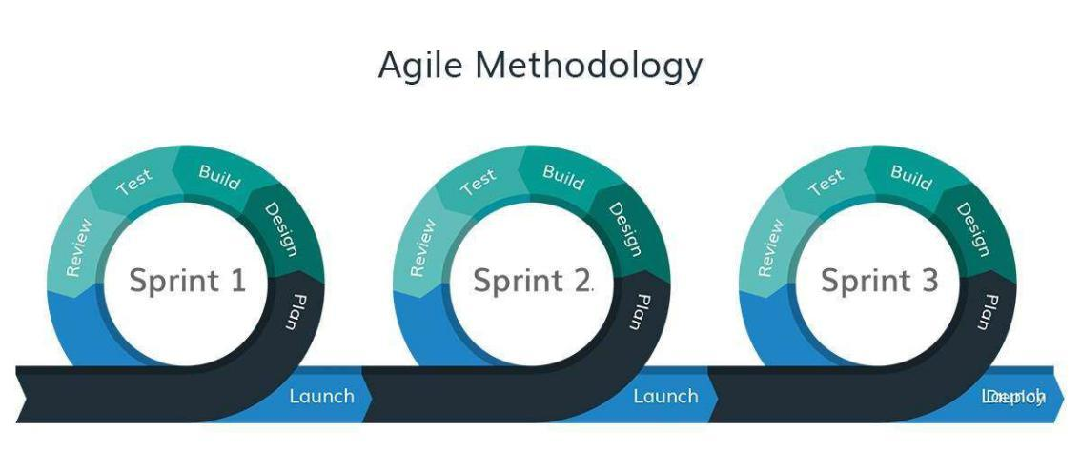needed to be implemented. Agile means faster product release since less time is there to complete the project So, this is appropriate method of software development. [4]

**Figure 1: Agile Methodology**

### 3.1.1. Requirement Specification

The software requirements are description of features and functionality of the target system. Requirements convey the expectations of users from the software product. The requirements can be obvious or hidden, known or unknown, expected or unexpected from client’s point of view. So, it's important to make them clear both for the development team and the stakeholders. The known requirements of the system to be developed are divided into two categories (functional and non-functional) and are mentioned below:

**i. Functional Requirements**

1. System should allow Customer to order the Product.
2. System should allow admin to add, update, and delete product details.
3. System should allow to view the product details.
4. Customer can search the products.
5. Customer should be able to make payment through the website.
6. Customer Order Details report should be generated.
7. Customer can review the products.
8. Customer can give feedback the products.

**ii. Non Functional Requirements**

**Reliability:** This System is easy to use and doesn't have high system requirements. So, the system is reliable.

**Compatibility:** The System should work seamlessly across different web browsers and devices to provide a consistent experience.

**Security:** The System will be secure, and the admin can only access the user and system informationl.

**Usability:** The system user interface is intuitive and user-friendly, ensuring users can navigate it easily.

**Maintainability:** The System has fewer hardware requirements and can be maintained within an affordable budget in case of technical errors.

**Response Time**: The System consistently provides timely responses to user/admin actions to keep their experience smooth.

**3.1.2. Feasibility Study**

A feasibility study is a way to evaluate the practicality and desirability of a project. Before a company invests time and money into a project, they need to know how successful the project will be before investing. Sometimes companies want to understand input costs, the amount of research that will need to be done, or even the marketability of a project.

**Table 1: Feasibility Analysis**

|  |  |  |
| --- | --- | --- |
| Name | Description | Remarks |
| **Technical Feasibility** | It is developed under Linux Operating System Using wordpress | Therefore, considering the requirement of the system is easily accessible the system is technologically feasible. |
| **Operational Feasibility** | The system is designed under Content Management System. | As it is user-friendly designed, the system is operationally feasible. |
| **Economic Feasibility** | The system is built using free software technologies and there is no any recurring cost just internet connection is needed. | Since open source technologies are used and there is no extra cost needed, the system is economically feasible. |

### 3.1.4. Process Modeling (DFD)

**Context Diagram**

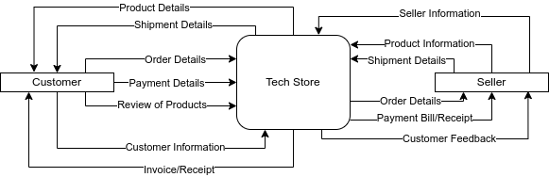

**Figure 2: Context Diagram**

## 3.2. System Design

### 3.2.1. System Architecture

A System architecture diagram also known as block diagram is a diagram of a system in which the principal parts or functions are represented by blocks connected by lines that show the relationships of the blocks. The block diagrams below show a simple visual representation for describing actions of the complex system. The blocks are often referred as black boxes, which represent mathematical or logical operations that occur in sequence. The base architecture of the system to be developed is shown below where basic pictorial representation has been drawn to narrate the overview of the system.

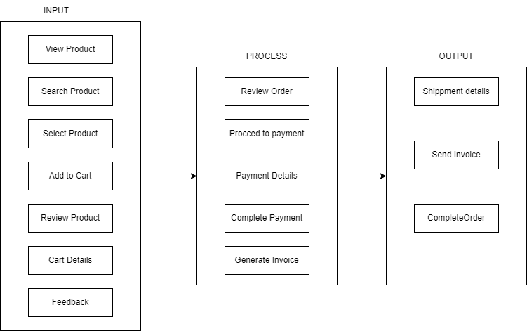

**Figure 3: System Architecture**

### 3.2.3. Interface Design (UI Interface/ Interface Structure Diagrams)

The user interface for this software will start from a welcome splash screen. Users will be prompted to the respective dashboard. The dashboard are designed in such a way that they can easily manage and manipulate the data and information they have access to. Furthermore, they will get interfaces accordingly depending on what action they perform. Tool-tips are placed in ambiguous component so that users will get better experience. Since Customer gets access to minimum actions, the interface is also organized in a way that user can easily access actions via menu bar. Samples for UI (Screenshots) are shown below at Appendices.

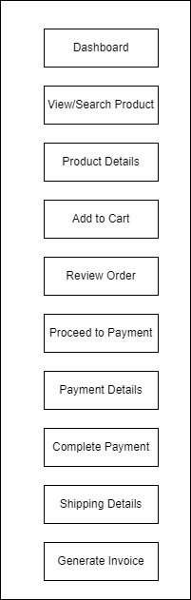

**Figure 4: UI Interface**

# Chapter 4: Implementation and Testing

## 4.1. Implementation

### 4.1.1. Tools Used

**Wordpress**WordPress is a versatile and user-friendly platform for website creation and management. With its intuitive interface and extensive customization options, users can easily build stunning websites tailored to their unique needs. From personal blogs to e-commerce stores and corporate portals, WordPress empowers individuals and businesses to establish a compelling online presence. Its vast library of themes and plugins, coupled with robust community support, ensures that users have the tools and resources needed to bring their vision to life. With millions of websites powered by WordPress worldwide, it remains the go-to choice for anyone looking to create impactful digital experiences.

### 4.1.2. Plugins Used

**WooCommerce**

WooCommerce is a versatile and user-friendly e-commerce plugin designed for WordPress websites. With WooCommerce, users can effortlessly transform their WordPress site into a fully functional online store. Offering a plethora of features including customizable storefronts, easy product management, secure payment gateways, and comprehensive order management tools, WooCommerce caters to businesses of all sizes and industries. Its seamless integration with WordPress and extensive library of extensions make it a popular choice among entrepreneurs looking to establish a robust online presence and drive sales. Whether selling physical products, digital downloads, or services, WooCommerce provides the tools and flexibility needed to create successful e-commerce ventures.

**Elementor**

Elementor is a popular drag-and-drop page builder plugin for WordPress, allowing users to create stunning websites with ease. With its intuitive interface and extensive library of widgets and templates, Elementor empowers users to design custom layouts without any coding knowledge. From simple landing pages to complex websites, Elementor streamlines the website building process, making it accessible to users of all skill levels. Its responsive design capabilities ensure that websites look great on any device, further enhancing the user experience. Overall, Elementor revolutionizes website design by offering a user-friendly and flexible solution for WordPress users.

窗体底端

**e-Sewa**:

eSewa – Nepal First Payment Gateway plugin enables any user with a wordpress site to integrate eSewa payment gateway in their website/web application. eSewa is Nepal’s first online payment gateway and is a comprehensive online payment solution. It is widely popular, secure as well as one of the most trusted online payment gateway. The following plugin incorporates itself with WordPress woo-commerce plugin and lets users pay via their eSewa id to buy any virtual goods or services.

## 4.2. Testing

Unit and integration testing is done in each module. In Unit testing small testable parts of the application are tested individually and independently. The team members themselves did unit test and the test was used for database test, records of each table, basic function test, add product, product order, Order Confirmation, Refund.

In integration testing, each module is combined and tested as a group. This test verified that the system maintained data integrity and can operate in coordination with other systems in the same environment. The team members themselves carried out the test.

### 4.2.1. Test cases for Unit Testing:

**a. Test case for Add to Cart**

**Table 2: Test case for Add to Cart**

|  |  |  |  |
| --- | --- | --- | --- |
| **S.N** | **Test Case** | **Expected Result** | **Remarks** |
| **1** | Enter the number of products to the cart equal to 0 | System should display message the value must be greater than 0. | Pass |
| **2** | Enter the number of products greater than 0. | System should add the number of product entered into the cart. | Pass |

**b. Test case for Checkout**

**Table 3 Test case for Checkout**

|  |  |  |  |  |
| --- | --- | --- | --- | --- |
| **S.N** | **Test Case** | **Description** | **Expected result** | **Remarks** |
| **1.** | Enter Billing First & Last Name | Enter the name of the customer. | System should enter the name of the customer. | Pass |
| **2.** | Select the Country/Region | Select the respective country or region | System should select the respective country. | Pass |
| **3.** | Enter the Street Address | Enter the street address of the customer | System should enter the customer address. | Pass |
| **4.** | Searching products | Enter product name | System Should display the searched product. | Pass |
| **5.** | Enter phone number | Enter the 10 number length phone number | System should enter the phone number. | Pass |
| **6** | Enter the Email address | Enter the proper format email address | System should enter the email address. | Pass |

# Chapter 5: Conclusion and Future Recommendation

## 5.1. Lesson Learnt

The primary objective of this project was to develop a comprehensive system facilitating online trading of goods and services, including secure online payment processing. Key features of the system include product management, order confirmation, and seamless online payment integration. One of the significant takeaways from this project was the importance of effective time management, particularly in prioritizing system components based on their complexity. This underscores the necessity for software developers to conduct thorough research and efficiently explore available options in their daily coding endeavors. Additionally, it is crucial for developers to opt for the most suitable and user-friendly solutions to ensure the success and usability of the software.

## 5.2. Conclusion

The creation of this ecommerce website aimed to revolutionize the traditional buying and selling processes by introducing modern online methods. The primary objective of the system is to facilitate online trading activities, including online payment processing, product tracking, and refund management. Following its successful development, the ecommerce website has effectively met all predefined objectives, enabling the store to seamlessly conduct trading activities online.

## 5.3. Future Recommendation

For future enhancements, it is recommended to focus on optimizing user experience and expanding functionality to stay competitive in the ever-evolving ecommerce landscape. Implementing features such as personalized product recommendations based on user preferences and browsing history can enhance customer engagement and drive sales. Additionally, integrating advanced analytics tools can provide valuable insights into customer behavior and purchasing patterns, enabling data-driven decision-making for targeted marketing strategies. Furthermore, exploring emerging technologies such as artificial intelligence and augmented reality to enhance product visualization and interactive shopping experiences can further differentiate the ecommerce website and attract tech-savvy consumers. Continuously monitoring industry trends and customer feedback will be essential for identifying opportunities for improvement and ensuring the ecommerce website remains innovative and relevant in the long term.

# APPENDICES

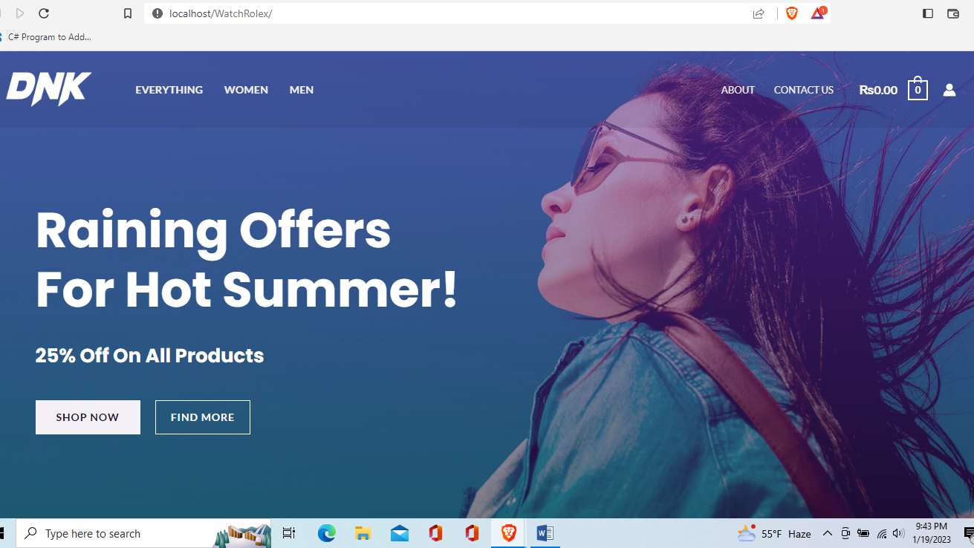

**Dashboard**

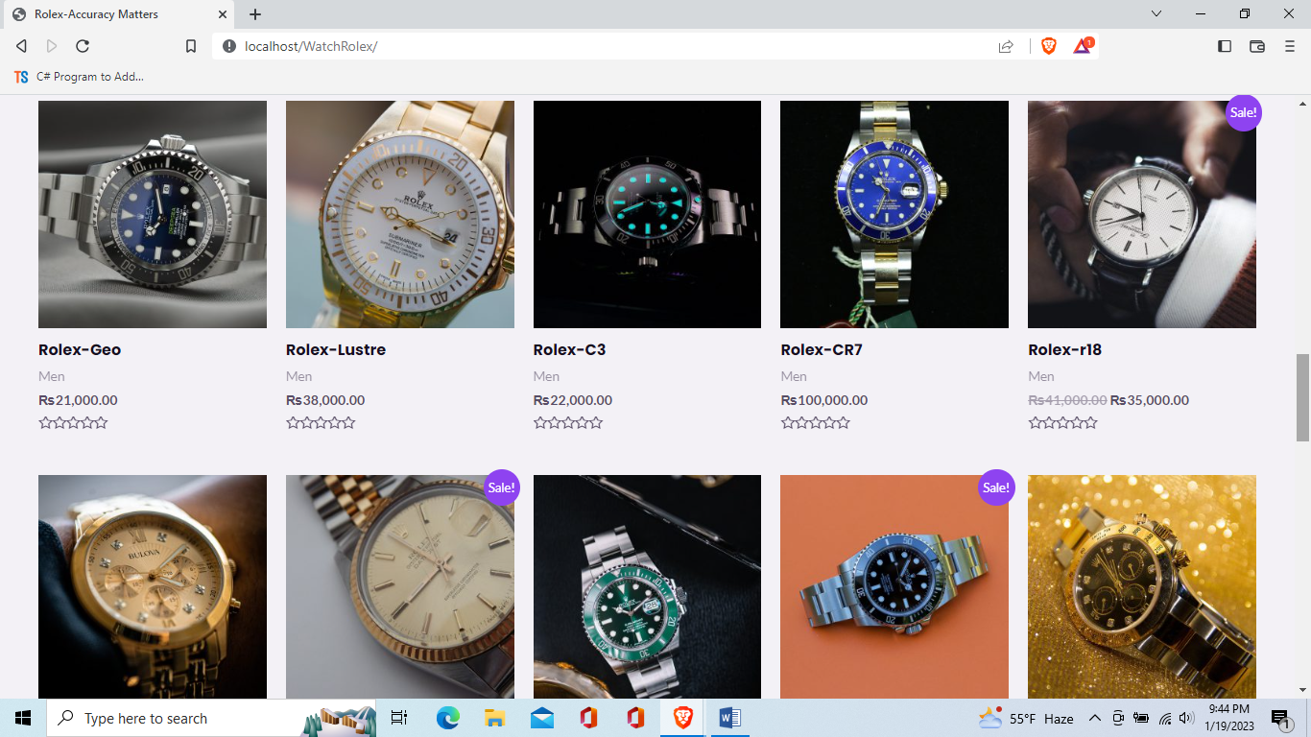

**Products page**

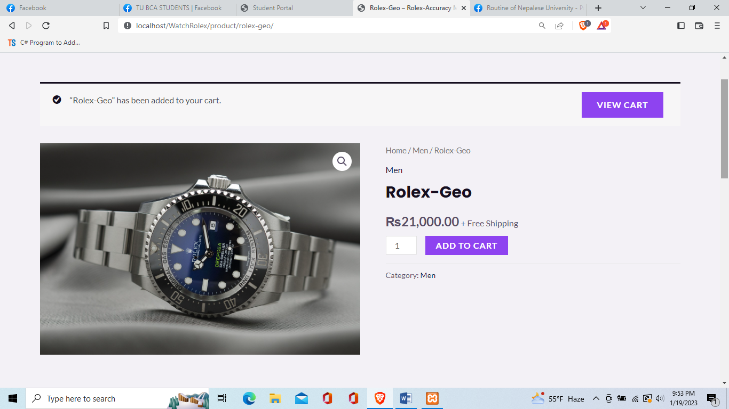

**Product Details**

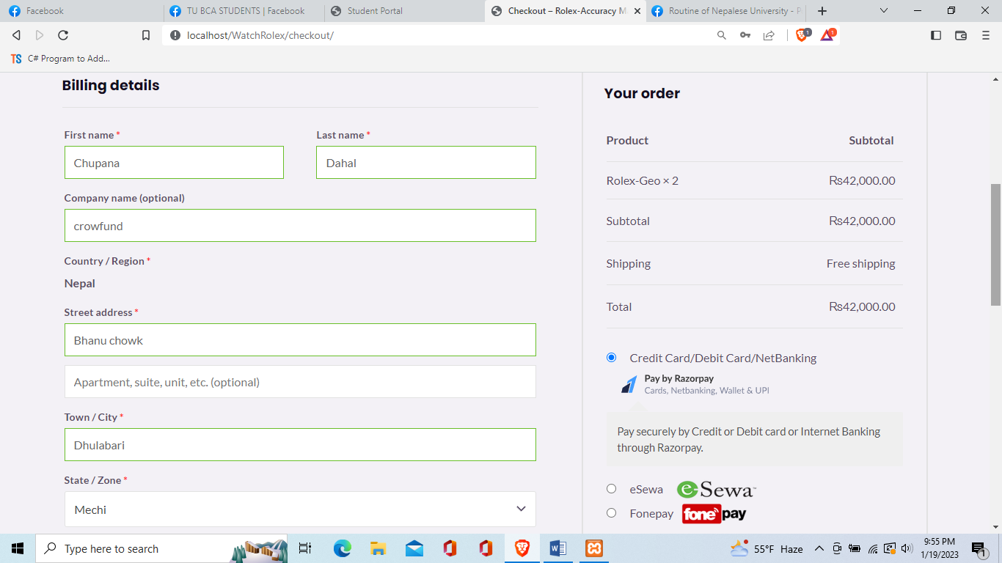

**Add to Cart**

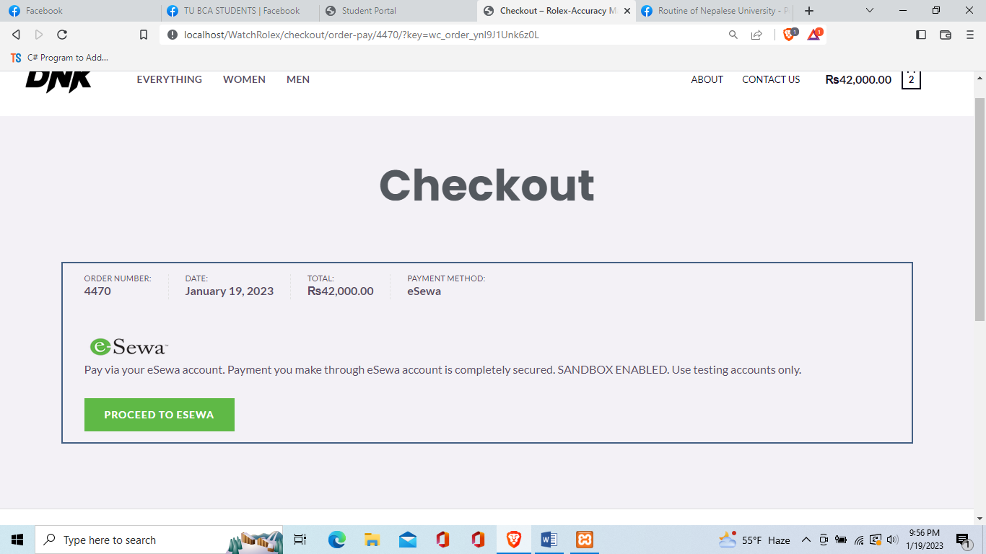

**Checkout**

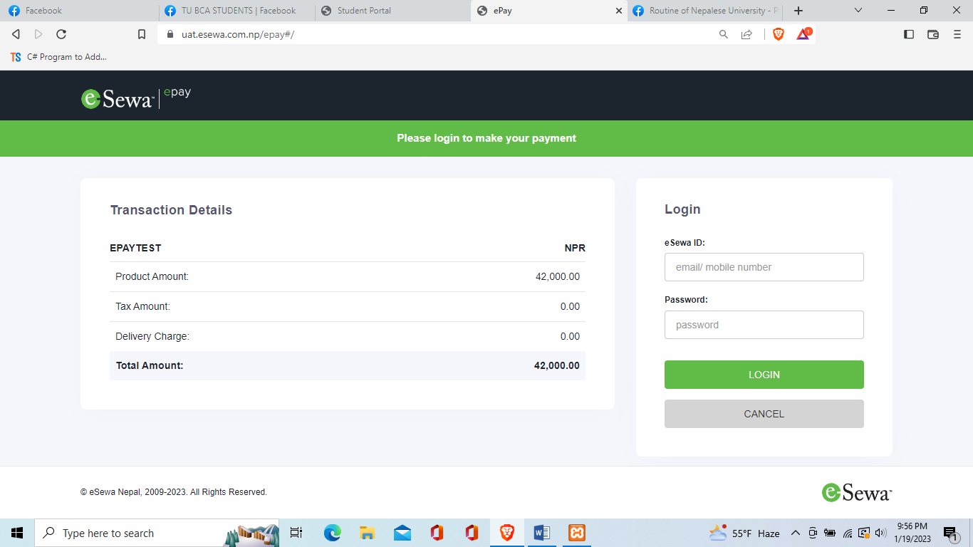

**E-Sewa Interface**